**Sorting Algorithms**



Session: 2021 – 2024

**Submitted by:**

Muhammad Danish 2021-CS-167

**Supervised by:**

Mam Maida Shahid

Department of Computer Science

**University of Engineering and Technology**

**Lahore Pakistan**

Contents

Short Description of Project: 4

Class Diagram: 4

Wireframes: 5

Execution Time Analysis: 6

For Sorted Data: 6

Discussion Paragraphs: 6

• Bubble Sort 6

• Insertion Sort: 7

• Selection Sort: 7

• Merge Sort: 7

• Quick Sort: 7

• Heap Sort: 8

• Counting Sort: 8

• Radix Sort: 8

• Bucket Sort: 8

For Unsorted Data: 9

Discussion paragraphs: 9

• Bubble Sort: 9

• Insertion Sort: 9

• Selection Sort: 9

• Merge Sort: 9

• Quick Sort: 10

• Heap Sort: 10

• Counting Sort: 10

• Radix Sort: 10

• Bucket Sort: 10

Full Code of CLI Project 11

CredentialBL: 11

Credential DL 12

CredentialUI 26

Driven Program 34

# Short Description of Project:

Basically, my project is all to all related to “Sorting Algorithms”. It Help us to recognized large amount of data into specific order. Sorting Algorithms take a list of data as input and return you the ordered array in specific order. Sorting plays a crucial role in all the algorithms that are related to data science. Total number of 9 Sorting Algorithms is discussed in the projects that help you to recognize its importance in different applications and solve complex problems related to sorting in easy way.

### Class Diagram:

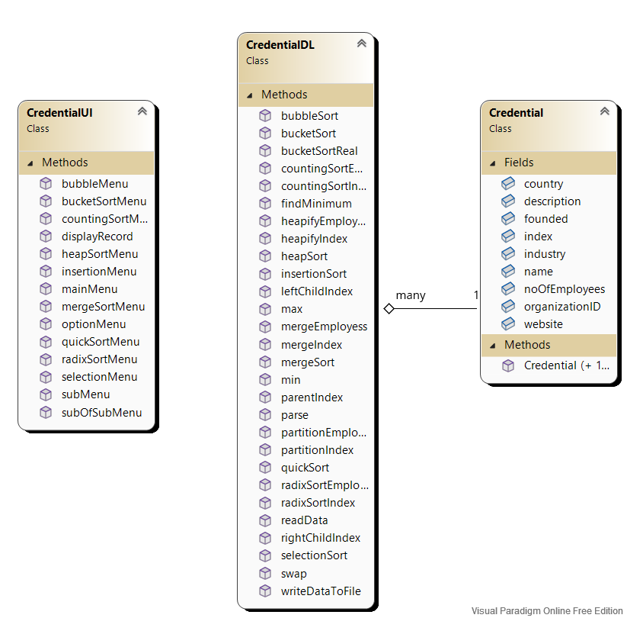

### Wireframes:

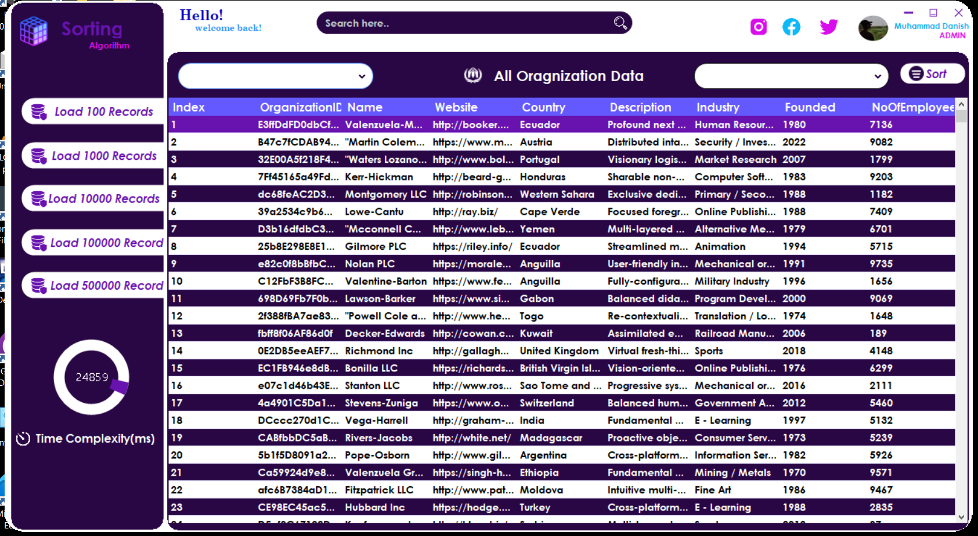

### Execution Time Analysis:

# For Sorted Data:

## Discussion Paragraphs:

### Bubble Sort

Basically, bubble sort is straightforward, simple and slow sorting algorithm. The reason behind why it is slow is that the each element is compare to another element at basis on condition and if condition satisfies then it is swap with that element. In this way we sort in ascending and descending order according to need. But if data is already sorted then we don’t need to sort this to overcome the time complexity to O(n) we make bool type swap element and put it into require condition and set its value then after inner loop iteration if the value is not set then it means data is already sorted then we break the loop. It is efficient when comparisons are not costly.

### Insertion Sort:

Basically, Insertion sort is efficient for small list of data and also for sorted data. It time complexity is also related to Bubble sort. It is efficient when comparisons are costly, because it makes less comparison to sort data as compare to other sorting algorithms because it rotates data one at a time. It also efficient when data is sorted because the require condition is not satisfy for sorted data and it takes its best time O (n) to sort data. But it’s also take O(n^2) time to sort data in worst case when all to all data is not sorted.

### **Selection** Sort:

Basically, Selection Sort improves the performance of bubble sort but also slow because in selection sort the smallest element is selected and swap against the largest element. The swapping is O(n) in selection sort as compared to bubble sort O(n^2). For Sorted Data its also take O(n^2) time to sort data because it always find minimum and then swap it with largest number in list.

### Merge Sort:

Basically, Merge Sort is well for very large sorting and also stable. It is fast recursive solution to sort data according to need. It follows divide and conquer rule to sort the data and divides list until it become unity then it merge the data according to require condition and then merge data in sorted way. For Sorted data it’s also take same time as for unsorted data because it follows divide and conquer rule and take (nlogn) time to sort data.

### Quick Sort:

Basically, Quick sort is fastest sorting algorithm in practice but unbalance partition lead to very slow sorting. For Sorted data if you always choose first element as a pivot then it takes O(n^2) time to sort data but if we choose randomly pivot then it can overcome the time complexity of sorting but may be it also leads to O(n^2) time.

### Heap Sort:

Basically, Heap Sort is most efficient version of selection sort but also slows than quick and merge sort. For Sorted Data it also take same time as for unsorted data because the worst time complexity is (nlogn) time because it also perform same procedure for sorted data first find Max then swap it with last element.

### Counting Sort:

Basically, Counting Sort is useful for repeated data to sort the data and also remain stable. For Sorted Data it also performs same procedure for unsorted because it is non-comparison sorting algorithm and also stable and unstable according to output loop we traverse. It take O(N+K) time to sort data where n is total input elements and K is total number of count list element.

### Radix Sort:

Basically, Radix Sort is improve version of counting sort but also use subroutine counting sorts because it does not depends on that range of integers is wide or not. For Sorted Data it also perform same procedure as for unsorted data because it’s a non-comparison base sorting algorithm and it also takes O(D*(N+K)) time to sort data.

### Bucket Sort:

Basically, Bucket Sort is useful to sort data decimal form of data in efficient way but also useful for integer base data because it makes bucket and put data in that buckets according to require condition and then sort the bucket according to every efficient algorithm. It does not take same time for sorted as for unsorted data because it also a non-comparison based sorting algorithm. Its Worst Case is that when all the buckets are full then it takes O(n^2) time to sort data.

# For Unsorted Data:

## Discussion paragraphs:

### Bubble Sort:

Basically, the reason behind why it is slow is that the each element is compare to another element at basis on condition and if condition satisfies then it is swap with that element. In this way we sort in ascending and descending order according to need. It is efficient when comparisons are not costly. For unsorted data it performs same procedure as above and takes O(n^2) to sort data.

### Insertion Sort:

Basically, it worst time complexity is also related to Bubble sort. It is efficient when comparisons are costly, because it makes less comparison to sort data as compare to other sorting algorithms because it rotates data one at a time. It’s also take O(n^2) time to sort data in worst case when all to all data is not sorted.

### Selection Sort:

Basically, in selection sort the smallest element is selected and swap against the largest element. For Unsorted Data it’s also take O(n^2) time to sort data because it always find minimum and then swap it with largest number in list.

### Merge Sort:

Basically, It follows divide and conquer rule to sort the data and divides list until it become unity then it merge the data according to require condition and then merge data in sorted way. For Unsorted data it’s also take same time as for sorted data because it follows divide and conquer rule and take (nlogn) time to sort data.

### Quick Sort:

Basically, for unsorted data if you always choose first element as a pivot then it takes O(nlogn) time to sort data but if we choose randomly pivot then it can overcome the time complexity of sorting but may be it also leads to O(nlogn) time.

### Heap Sort:

Basically, for unsorted data it also take same time as for sorted data because the Best time complexity is (nlogn) time because it also perform same procedure for sorted data first find Max then swap it with last element.

### Counting Sort:

Basically, for unsorted data it also performs same procedure for sorted because it is non-comparison sorting algorithm and also stable and unstable according to output loop we traverse. It take O(N+K) time to sort data where n is total input elements and K is total number of count list element.

### Radix Sort:

Basically, for unsorted data it also perform same procedure as for sorted data because it’s a non-comparison base sorting algorithm and it also takes O(D*(N+K)) time to sort data.

### Bucket Sort:

Basically, It does not takes same time for unsorted as for sorted data because it also a non-comparison based sorting algorithm. Its Best Case is that when all the buckets are full then it takes O(N+K) time to sort data for best case.

# Full Code of CLI Project

### **CredentialBL**:

#pragma once

#include <iostream>

using namespace std;

class Credential

{

public:

int index;

int founded;

int noOfEmployees;

string organizationID;

string name;

string website;

string country;

string description;

string industry;

Credential()

{

}

Credential(int index, int founded, int noOfEmployees, string organizationID, string name, string website, string country, string description, string industry)

{

this->index = index;

this->founded = founded;

this->noOfEmployees = noOfEmployees;

this->organizationID = organizationID;

this->name = name;

this->website = website;

this->country = country;

this->description = description;

this->industry = industry;

}

};

### Credential DL

#include<iostream>

#include"Credential.h"

#include <vector>

#include<string>

#include<fstream>

#include"queue"

#include<cmath>

#pragma once

using namespace std;

class CredentialDL

{

public:

static vector<Credential> readData(string path)

{

vector<Credential> record;

ifstream myFile;

myFile.open(path,ios::in);

string line;

getline(myFile, line);

while (myFile.good())

{

getline(myFile, line);

if (!line.empty())

{

int index = stoi(parse(line, 1));

string organizationID = parse(line, 2);

string name = parse(line, 3);

string website = parse(line, 4);

string country = parse(line, 5);

string description = parse(line, 6);

int founded = stoi(parse(line, 7));

string industry = parse(line, 8);

int noOfEmployees = stoi(parse(line, 9));

Credential cre(index, founded, noOfEmployees, organizationID, name, website, country, description, industry);

record.push_back(cre);

}

else

{

myFile.close();

}

}

myFile.close();

return record;

}

static string parse(string line, int find)

{

bool flag = true;

string parse = "";

int commas = 1;

int count = 0;

for (int i = 0; line[i] != '\0'; i++)

{

if (line[i] == ',')

{

if (flag)

{

commas++;

}

}

else if (commas == find)

{

parse = parse + line[i];

}

if (line[i] == '"')

{

flag = false;

count++;

}

if (count == 2)

{

flag = true;

count = 0;

}

}

return parse;

}

static vector<Credential> bubbleSort(vector<Credential> record, bool flag)

{

int size = record.size();

for (int x = 0; x < size - 1; x++)

{

bool isSwapped = false;

for (int y = 0; y < size - x - 1; y++)

{

int temp1, temp2;

if (flag)

{

temp1 = record[y].index;

temp2 = record[y + 1].index;

}

else

{

temp1 = record[y].noOfEmployees;

temp2 = record[y + 1].noOfEmployees;

}

if (temp1 > temp2)

{

swap(record[y], record[y + 1]);

isSwapped = true;

}

}

if (!isSwapped)

{

break;

}

}

return record;

}

static int findMinimum(vector<Credential> record, int start, int end, bool flag)

{

int min;

if (flag)

{

min = record[start].index;

}

else

{

min = record[start].noOfEmployees;

}

int minIndex = start;

for (int x = start; x < end; x++)

{

int temp;

if (flag)

{

temp = record[x].index;

}

else

{

temp = record[x].noOfEmployees;

}

if (min > temp)

{

min = temp;

minIndex = x;

}

}

return minIndex;

}

static vector<Credential> selectionSort(vector<Credential> record, bool flag)

{

int size = record.size();

for (int x = 0; x < size - 1; x++)

{

int minIndex = findMinimum(record, x, size, flag);

swap(record[x], record[minIndex]);

}

return record;

}

static vector<Credential> insertionSort(vector<Credential> record, bool flag)

{

int size = record.size();

for (int x = 1; x < size; x++)

{

int y, key;

if (flag)

{

key = record[x].index;

y = x - 1;

while (y >= 0 && record[y].index > key)

{

record[y + 1] = record[y];

y--;

}

}

else

{

key = record[x].noOfEmployees;

y = x - 1;

while (y >= 0 && record[y].noOfEmployees > key)

{

record[y + 1] = record[y];

y--;

}

}

record[y + 1] = record[x];

}

return record;

}

static void mergeEmployess(vector<Credential>& arr, int start, int mid, int end) {

int i = start;

int j = mid + 1;

queue<Credential> tempArr;

while (i <= mid && j <= end) {

if (arr[i].noOfEmployees < arr[j].noOfEmployees)

{

tempArr.push(arr[i]);

i++;

}

else

{

tempArr.push(arr[j]);

j++;

}

}

while (i <= mid) {

tempArr.push(arr[i]);

i++;

}

while (j <= end) {

tempArr.push(arr[j]);

j++;

}

for (int x = start; x <= end; x++) {

arr[x] = tempArr.front();

tempArr.pop();

}

}

static void mergeIndex(vector<Credential>& arr, int start, int mid, int end) {

int i = start;

int j = mid + 1;

queue<Credential> tempArr;

while (i <= mid && j <= end) {

if (arr[i].index < arr[j].index)

{

tempArr.push(arr[i]);

i++;

}

else

{

tempArr.push(arr[j]);

j++;

}

}

while (i <= mid) {

tempArr.push(arr[i]);

i++;

}

while (j <= end) {

tempArr.push(arr[j]);

j++;

}

for (int x = start; x <= end; x++) {

arr[x] = tempArr.front();

tempArr.pop();

}

}

static void mergeSort(vector<Credential>& arr, int start, int end, bool flag)

{

if (start < end)

{

int mid = (start + end) / 2;

mergeSort(arr, start, mid, flag);

mergeSort(arr, mid + 1, end, flag);

if (flag) {

mergeIndex(arr, start, mid, end);

}

else {

mergeEmployess(arr, start, mid, end);

}

}

}

static int partitionIndex(vector<Credential>& arr, int start, int end, int pivot)

{

int left = start;

int right = end;

while (left <= right)

{

while (left <= end && arr[left].index < arr[pivot].index)

left++;

while (right >= start && arr[right].index >= arr[pivot].index)

right--;

if (left < right)

swap(arr[left], arr[right]);

}

swap(arr[right], arr[pivot]);

return right;

}

static int partitionEmployees(vector<Credential>& arr, int start, int end, int pivot)

{

int left = start;

int right = end;

while (left <= right)

{

while (left <= end && arr[left].noOfEmployees < arr[pivot].noOfEmployees)

left++;

while (right >= start && arr[right].noOfEmployees >= arr[pivot].noOfEmployees)

right--;

if (left < right)

swap(arr[left], arr[right]);

}

swap(arr[right], arr[pivot]);

return right;

}

static void quickSort(vector<Credential>& arr, int start, int end, bool flag)

{

if (start < end)

{

int pivot = start;

int mid;

if (flag)

{

mid = partitionIndex(arr, start + 1, end, pivot);

}

else {

mid = partitionEmployees(arr, start + 1, end, pivot);

}

quickSort(arr, start, mid - 1, flag);

quickSort(arr, mid + 1, end, flag);

}

}

static int parentIndex(int i)

{

return (i - 1) / 2;

}

static int leftChildIndex(int i)

{

return (2 * i) + 1;

}

static int rightChildIndex(int i)

{

return (2 * i) + 2;

}

static void swap(Credential& a, Credential& b)

{

Credential temp = a;

a = b;

b = temp;

}

static void heapifyIndex(vector<Credential>& heapArr, int size, int index) {

int maxIndex;

while (true) {

int lIdx = leftChildIndex(index);

int rIdx = rightChildIndex(index);

if (rIdx >= size) {

if (lIdx >= size)

return;

else

maxIndex = lIdx;

}

else {

if (heapArr[lIdx].index >= heapArr[rIdx].index)

maxIndex = lIdx;

else

maxIndex = rIdx;

}

if (heapArr[index].index < heapArr[maxIndex].index) {

swap(heapArr[index], heapArr[maxIndex]);

index = maxIndex;

}

else

return;

}

}

static void heapifyEmployess(vector<Credential>& heapArr, int size, int index) {

int maxIndex;

while (true) {

int lIdx = leftChildIndex(index);

int rIdx = rightChildIndex(index);

if (rIdx >= size) {

if (lIdx >= size)

return;

else

maxIndex = lIdx;

}

else {

if (heapArr[lIdx].noOfEmployees >= heapArr[rIdx].noOfEmployees)

maxIndex = lIdx;

else

maxIndex = rIdx;

}

if (heapArr[index].noOfEmployees < heapArr[maxIndex].noOfEmployees) {

swap(heapArr[index], heapArr[maxIndex]);

index = maxIndex;

}

else

return;

}

}

static void heapSort(vector<Credential>& heapArr, int size, bool flag)

{

for (int x = (size / 2) - 1; x >= 0; x--)

{

if (flag)

{

heapifyIndex(heapArr, size, x);

}

else {

heapifyEmployess(heapArr, size, x);

}

}

for (int x = size - 1; x > 0; x--)

{

swap(heapArr[0], heapArr[x]);

if (flag)

{

heapifyIndex(heapArr, x, 0);

}

else {

heapifyEmployess(heapArr, x, 0);

}

}

}

static bool writeDataToFile(vector<Credential> record, string path)

{

ofstream myFile;

myFile.open(path, ios::out);

myFile << "index" << "," << " Organization ID" << "," << "Name" << "," << "Website" << "," << "Country" << "," << "Description" << "," << "Founded" << "," << "Industry" << "," << "No of Employees" << endl;

for (int i = 0; i < record.size(); i++)

{

myFile << record[i].index << "," << record[i].organizationID << "," << record[i].name << "," << record[i].website << ","

<< record[i].country << "," << record[i].description << "," << record[i].founded << "," << record[i].industry << "," << record[i].noOfEmployees << endl;

}

myFile.close();

return true;

}

static int max(vector<Credential> arr, bool flag)

{

int max;

if (flag)

{

max = arr[0].index;

}

else

{

max = arr[0].noOfEmployees;

}

for (int i = 1; i < arr.size(); i++)

{

int value;

if (flag)

{

value = arr[i].index;

}

else

{

value = arr[i].noOfEmployees;

}

if (max < value)

{

max = value;

}

}

return max;

}

static int min(vector<Credential> arr, bool flag)

{

int min;

if (flag)

{

min = arr[0].index;

}

else

{

min = arr[0].noOfEmployees;

}

for (int i = 1; i < arr.size(); i++)

{

int value;

if (flag)

{

value = arr[i].index;

}

else

{

value = arr[i].noOfEmployees;

}

if (min > value)

{

min = value;

}

}

return min;

}

static void countingSortIndex(vector<Credential>& arr, int place, bool radix)

{

int range = 0, maximum = 0, minimum = 0;

if (radix)

{

range = 10;

}

else

{

maximum = max(arr, true);

minimum = min(arr, true);

range = maximum - minimum + 1;

}

vector<int> count(range);

vector<Credential> output(arr.size());

for (int i = 0; i < arr.size(); i++)

{

if (radix)

{

count[((arr[i].index / place) % 10)]++;

}

else

{

count[arr[i].index - minimum]++;

}

}

for (int i = 1; i < count.size(); i++)

{

count[i] += count[i - 1];

}

for (int i = arr.size() - 1; i >= 0; i--)

{

if (radix)

{

output[count[((arr[i].index / place) % 10)] - 1] = arr[i];

count[((arr[i].index / place) % 10)]--;

}

else

{

output[count[arr[i].index - minimum] - 1] = arr[i];

count[arr[i].index - minimum]--;

}

}

arr = output;

}

static void countingSortEmployee(vector<Credential> arr, int place, bool radix)

{

int range = 0, maximum = 0, minimum = 0;

if (radix)

{

range = 10;

}

else

{

maximum = max(arr, false);

minimum = min(arr, false);

range = maximum - minimum + 1;

}

vector<int> count(range);

vector<Credential> output(arr.size());

for (int i = 0; i < arr.size(); i++)

{

if (radix)

{

count[(arr[i].noOfEmployees / place) % 10]++;

}

else

{

count[arr[i].noOfEmployees - minimum]++;

}

}

for (int i = 1; i < count.size(); i++)

{

count[i] += count[i - 1];

}

for (int i = arr.size() - 1; i >= 0; i--)

{

if (radix)

{

output[count[(arr[i].noOfEmployees / place) % 10] - 1] = arr[i];

count[(arr[i].noOfEmployees / place) % 10]--;

}

else

{

output[count[arr[i].noOfEmployees - minimum] - 1] = arr[i];

count[arr[i].noOfEmployees - minimum]--;

}

}

arr = output;

}

static void radixSortIndex(vector<Credential>& arr)

{

int maximum = max(arr, true);

int place = 1;

while (maximum / place > 0)

{

countingSortIndex(arr, place, true);

place *= 10;

}

}

static void radixSortEmployee(vector<Credential>& arr)

{

int maximum = max(arr, false);

int place = 1;

while (maximum / place > 0)

{

countingSortEmployee(arr, place, true);

place *= 10;

}

}

static void bucketSort(vector<Credential>& arr, bool flag)

{

int maximum;

if (flag)

{

maximum = max(arr, true);

}

else

{

maximum = max(arr, false);

}

int n = ceil(sqrt(arr.size())) + 1;

int indx = ceil((maximum + 1) / n);

vector<vector<Credential>> bucket(maximum / indx + 1);

for (int i = 0; i < arr.size(); i++) {

int idx;

if (flag)

{

idx = arr[i].index / indx;

}

else {

idx = arr[i].noOfEmployees / indx;

}

bucket[idx].push_back(arr[i]);

}

for (int i = 0; i < bucket.size(); i++)

if (flag)

{

countingSortIndex(bucket[i], 0, false);

}

else

{

countingSortEmployee(bucket[i], 0, false);

}

int index = 0;

for (int i = 0; i < bucket.size(); i++)

for (int j = 0; j < bucket[i].size(); j++)

arr[index++] = bucket[i][j];

}

static void bucketSortReal(vector<Credential>&arr, bool flag)

{

int maximum;

if (flag) {

maximum = max(arr, true);

}

else {

maximum = max(arr, false);

}

vector<vector<Credential>> bucket(maximum + 1);

for (int i = 0; i < arr.size(); i++) {

int idx;

if (flag) {

idx = arr[i].index;

}

else {

idx = arr[i].noOfEmployees;

}

bucket[idx].push_back(arr[i]);

}

int index = 0;

for (int i = 0; i < bucket.size(); i++)

for (int j = 0; j < bucket[i].size(); j++)

arr[index++] = bucket[i][j];

}

};

### CredentialUI

#include<iostream>

#include "Credential.h"

#include "SystemTime.h"

#include "CredentialDL.h"

#pragma once

using namespace std;

class CredentialUI

{

public:

static int mainMenu()

{

int option;

cout << "1 -> Load 100 Records" << endl;

cout << "2 -> Load 1000 Records" << endl;

cout << "3 -> Load 10000 Records" << endl;

cout << "4 -> Load 100000 Records" << endl;

cout << "5 -> Load 500000 Records" << endl;

cout << "6 -> EXIT" << endl;

cout << "Select one option -> ";

cin >> option;

return option;

}

static int subMenu()

{

int option;

cout << "1 -> Bubble Sort Algorithm" << endl;

cout << "2 -> Insertion Sort Algorithm" << endl;

cout << "3 -> Selection Sort Algorithm" << endl;

cout << "4 -> Merge Sort Algorithm" << endl;

cout << "5 -> Quick Sort Algorithm" << endl;

cout << "6 -> Heap Sort Algorithm" << endl;

cout << "7 -> Counting Sort Algorithm" << endl;

cout << "8 -> Radix Sort Algorithm" << endl;

cout << "9 -> Bucket Sort Algorithm" << endl;

cout << "10 -> Back" << endl;

cout << "Select one option -> ";

cin >> option;

return option;

}

static int subOfSubMenu()

{

int option;

cout << "1 -> Base On Indexes" << endl;

cout << "2 -> Base On Number Of Employess" << endl;

cout << "3 -> Back" << endl;

cout << "Select one option -> ";

cin >> option;

return option;

}

static void displayRecord(vector<Credential> record)

{

for (int i = 0; i < record.size() - 1; i++)

{

cout << record[i].index << " " << record[i].organizationID << " " << record[i].name << " " << record[i].country << " " << record[i].website

<< " " << record[i].founded << " " << record[i].industry << " " << record[i].description << " " << record[i].noOfEmployees << endl;

}

}

static void bubbleMenu(vector<Credential> record, vector<Credential>& sortRecord)

{

int subOfSubOption = 0;

while (subOfSubOption != 3)

{

system("CLS");

subOfSubOption = CredentialUI::subOfSubMenu();

system("CLS");

SystemTime time;

time.BeforeOperation();

if (subOfSubOption == 1)

{

sortRecord = CredentialDL::bubbleSort(record, true);

}

else if (subOfSubOption == 2)

{

sortRecord = CredentialDL::bubbleSort(record, false);

}

else

{

break;

}

time.AfterOperation();

time.TimeDifference();

system("pause");

CredentialDL::writeDataToFile(sortRecord, "Danish.csv");

}

}

static void insertionMenu(vector<Credential> record, vector<Credential>& sortRecord)

{

int subOfSubOption = 0;

while (subOfSubOption != 3)

{

system("CLS");

subOfSubOption = CredentialUI::subOfSubMenu();

system("CLS");

SystemTime time;

time.BeforeOperation();

if (subOfSubOption == 1)

{

sortRecord = CredentialDL::insertionSort(record, true);

}

else if (subOfSubOption == 2)

{

sortRecord = CredentialDL::insertionSort(record, false);

}

else

{

break;

}

time.AfterOperation();

time.TimeDifference();

system("pause");

CredentialDL::writeDataToFile(sortRecord, "Danish.csv");

}

}

static void selectionMenu(vector<Credential> record, vector<Credential>& sortRecord)

{

int subOfSubOption = 0;

while (subOfSubOption != 3)

{

system("CLS");

subOfSubOption = CredentialUI::subOfSubMenu();

system("CLS");

SystemTime time;

time.BeforeOperation();

if (subOfSubOption == 1)

{

sortRecord = CredentialDL::selectionSort(record, true);

}

else if (subOfSubOption == 2)

{

sortRecord = CredentialDL::selectionSort(record, false);

}

else

{

break;

}

time.AfterOperation();

time.TimeDifference();

system("pause");

CredentialDL::writeDataToFile(sortRecord, "Danish.csv");

}

}

static void mergeSortMenu(vector<Credential> record)

{

int subOfSubOption = 0;

while (subOfSubOption != 3)

{

system("CLS");

subOfSubOption = CredentialUI::subOfSubMenu();

system("CLS");

int size = record.size() - 1;

SystemTime time;

time.BeforeOperation();

if (subOfSubOption == 1)

{

CredentialDL::mergeSort(record, 0, size, true);

}

else if (subOfSubOption == 2)

{

CredentialDL::mergeSort(record, 0, size, false);

}

else

{

break;

}

time.AfterOperation();

time.TimeDifference();

system("pause");

CredentialDL::writeDataToFile(record, "Danish.csv");

}

}

static void quickSortMenu(vector<Credential> record)

{

int subOfSubOption = 0;

while (subOfSubOption != 3)

{

system("CLS");

subOfSubOption = CredentialUI::subOfSubMenu();

system("CLS");

int size = record.size() - 1;

SystemTime time;

time.BeforeOperation();

if (subOfSubOption == 1)

{

CredentialDL::quickSort(record, 0, size, true);

}

else if (subOfSubOption == 2)

{

CredentialDL::quickSort(record, 0, size, false);

}

else

{

break;

}

time.AfterOperation();

time.TimeDifference();

system("pause");

CredentialDL::writeDataToFile(record, "Danish.csv");

}

}

static void heapSortMenu(vector<Credential> record)

{

int subOfSubOption = 0;

while (subOfSubOption != 3)

{

system("CLS");

subOfSubOption = CredentialUI::subOfSubMenu();

system("CLS");

int size = record.size() - 1;

SystemTime time;

time.BeforeOperation();

if (subOfSubOption == 1)

{

CredentialDL::heapSort(record, size, true);

}

else if (subOfSubOption == 2)

{

CredentialDL::heapSort(record, size, false);

}

else

{

break;

}

time.AfterOperation();

time.TimeDifference();

system("pause");

CredentialDL::writeDataToFile(record, "Danish.csv");

}

}

static void countingSortMenu(vector<Credential> record)

{

int subOfSubOption = 0;

while (subOfSubOption != 3)

{

system("CLS");

subOfSubOption = CredentialUI::subOfSubMenu();

system("CLS");

SystemTime time;

time.BeforeOperation();

if (subOfSubOption == 1)

{

system("pause");

CredentialDL::countingSortIndex(record, 0, false);

}

else if (subOfSubOption == 2)

{

CredentialDL::countingSortEmployee(record, 0, false);

}

else

{

break;

}

time.AfterOperation();

time.TimeDifference();

system("pause");

CredentialDL::writeDataToFile(record, "Danish.csv");

}

}

static void radixSortMenu(vector<Credential> record)

{

int subOfSubOption = 0;

while (subOfSubOption != 3)

{

system("CLS");

subOfSubOption = CredentialUI::subOfSubMenu();

system("CLS");

SystemTime time;

time.BeforeOperation();

if (subOfSubOption == 1)

{

CredentialDL::radixSortIndex(record);

}

else if (subOfSubOption == 2)

{

CredentialDL::radixSortEmployee(record);

}

else

{

break;

}

time.AfterOperation();

time.TimeDifference();

system("pause");

CredentialDL::writeDataToFile(record, "Danish.csv");

}

}

static void bucketSortMenu(vector<Credential> record)

{

int subOfSubOption = 0;

while (subOfSubOption != 3)

{

system("CLS");

subOfSubOption = CredentialUI::subOfSubMenu();

system("CLS");

SystemTime time;

time.BeforeOperation();

if (subOfSubOption == 1)

{

CredentialDL::bucketSort(record,true);

}

else if (subOfSubOption == 2)

{

CredentialDL::bucketSort(record,false);

}

else

{

break;

}

time.AfterOperation();

time.TimeDifference();

system("pause");

CredentialDL::writeDataToFile(record, "Danish.csv");

}

}

static void optionMenu(vector<Credential> record, vector<Credential>& sortRecord)

{

int subOption = 0;

while (subOption != 10)

{

system("CLS");

subOption = subMenu();

if (subOption == 1)

{

bubbleMenu(record, sortRecord);

}

else if (subOption == 2)

{

insertionMenu(record, sortRecord);

}

else if (subOption == 3)

{

selectionMenu(record, sortRecord);

}

else if (subOption == 4)

{

sortRecord = record;

mergeSortMenu(sortRecord);

}

else if (subOption == 5)

{

sortRecord = record;

quickSortMenu(sortRecord);

}

else if (subOption == 6)

{

sortRecord = record;

heapSortMenu(sortRecord);

}

else if (subOption == 7)

{

sortRecord = record;

countingSortMenu(sortRecord);

}

else if (subOption == 8)

{

sortRecord = record;

radixSortMenu(sortRecord);

}

else if (subOption == 9)

{

sortRecord = record;

bucketSortMenu(record);

}

}

return;

}

};

### Driven Program

#include "SortingAlgorithm.h"

#include "Credential.h"

#include"CredentialDL.h"

#include"CredentialUI.h"

#include<vector>

#include"SystemTime.h"

using namespace std;

int main()

{

vector<Credential> record;

vector<Credential> sortRecord;

int option = 0;

while (option != 5)

{

system("CLS");

option = CredentialUI::mainMenu();

if (option == 1)

{

record = CredentialDL::readData("organizations-100.csv");

cout << record.size();

CredentialUI::optionMenu(record, sortRecord);

}

else if (option == 2)

{

record = CredentialDL::readData("organizations-1000.csv");

CredentialUI::optionMenu(record, sortRecord);

}

else if (option == 3)

{

record = CredentialDL::readData("organizations-10000.csv");

CredentialUI::optionMenu(record, sortRecord);

}

else if (option == 4)

{

record = CredentialDL::readData("organizations-100000.csv");

CredentialUI::optionMenu(record, sortRecord);

}

else if (option == 5)

{

record = CredentialDL::readData("organizations-500000.csv");

CredentialUI::optionMenu(record, sortRecord);

}

}

};

**Important Instructions**

**Here you can find the major parts of your documentation**

* Table of Contents
* Short Description of your project
* Class Diagram of CLI project
* Wire Frames of your GUI
* Execution Time Analysis (in a Table) for the 5 data sets of Organizations Data of the 9 sorting algorithms
  + For Sorted Data
    - 1 Paragraph on the discussion of each Algorithm why it is taking the reported time
  + For Unsorted Data
    - 1 Paragraph on the discussion of each Algorithm why it is taking the reported time
* Full Code of CLI project

**Formatting Instructions**

1. Heading Size is 16
2. Sub heading size is 14
3. Further heading size is 13
4. Make your heading font bold
5. Text Font size is 12
6. Use Times New Roman Font Style
7. Text paragraphs should be justified. (Justify is feature of MS World)
8. Code Size should be 10 and 1.0 line Spacing to make it compact
9. Follow proper coding Styles to make the classes and driver program
10. All the 9 sorting Algorithms should be implemented.
    1. Bubble Sort
    2. Selection Sort
    3. Insertion Sort
    4. Merge Sort
    5. Quick Sort
    6. Heap Sort
    7. Counting Sort
    8. Radix Sort
    9. Bucket Sort